2.Spring-rest-handson

**REST - Country Web Service**

**Country.java :**

package com.cognizant.spring_learn;

import org.slf4j.Logger;

import org.slf4j.LoggerFactory;

public class Country {

private static final Logger LOGGER = LoggerFactory.getLogger(Country.class);

private String code;

private String name;

public Country() {

LOGGER.debug("Inside Country Constructor");

}

public String getCode() {

LOGGER.debug("Inside getCode()");

return code;

}

public void setCode(String code) {

LOGGER.debug("Inside setCode()");

this.code = code;

}

public String getName() {

LOGGER.debug("Inside getName()");

return name;

}

public void setName(String name) {

LOGGER.debug("Inside setName()");

this.name = name;

}

@Override

public String toString() {

return "Country [code=" + code + ", name=" + name + "]";

}

}

**CountryController.java :**

package com.cognizant.spring_learn.controller;

import com.cognizant.spring_learn.Country;

import org.slf4j.Logger;

import org.slf4j.LoggerFactory;

import org.springframework.context.ApplicationContext;

import org.springframework.context.support.ClassPathXmlApplicationContext;

import org.springframework.web.bind.annotation.RequestMapping;

import org.springframework.web.bind.annotation.RestController;

@RestController

public class CountryController {

private static final Logger LOGGER = LoggerFactory.getLogger(CountryController.class);

@RequestMapping("/country")

public Country getCountryIndia() {

LOGGER.info("START");

ApplicationContext context = new ClassPathXmlApplicationContext("country.xml");

Country country = context.getBean("country", Country.class);

LOGGER.debug("Country: {}", country.toString());

LOGGER.info("END");

return country;

}

}

**SpringLearnApplication :**

package com.cognizant.spring_learn;

import org.slf4j.Logger;

import org.slf4j.LoggerFactory;

import org.springframework.boot.SpringApplication;

import org.springframework.boot.autoconfigure.SpringBootApplication;

@SpringBootApplication

public class SpringLearnApplication {

private static final Logger LOGGER = LoggerFactory.getLogger(SpringLearnApplication.class);

public static void main(String[] args) {

LOGGER.info("START");

SpringApplication.run(SpringLearnApplication.class, args);

LOGGER.info("END");

}

}

**OUTPUT :**

**IN CHROME BROWSER :**

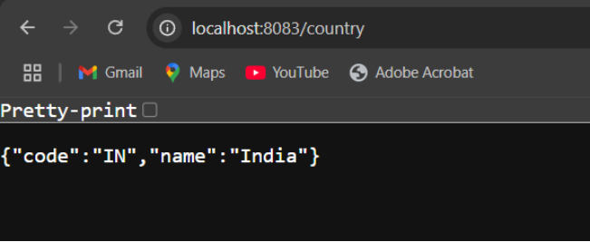

**IN POST MAN :**

